EDIFY: CRITICAL NEXUS II: VADDE, TWITTER, WSGR, BIDEN & DURBAN
9 October 2022|COVID-19, EDIFY INTEL
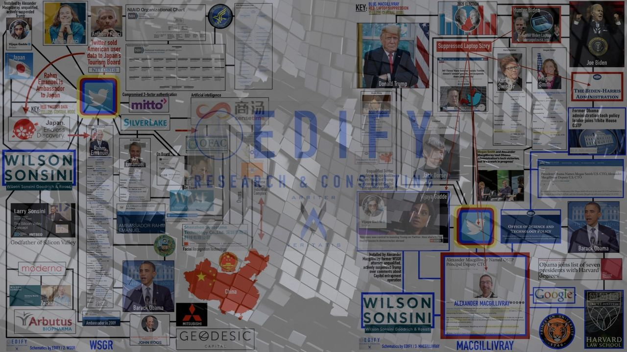
09 OCT 22 / MONTANA, USA
PRIMARY SUBJECTS: Wilson Sonsini Goodrich & Rosati, Twitter, Biden White House, Obama White House, James Baker, Alexander Macgillivray, Vijaya Gadde
In conjunction with a client who remains confidential, EDIFY developed the nexus schematics featured in the FIRST BRIEF that are well-evidenced and identify and connect a slate of important individuals, entities and nations respective to a wide swath of past and ongoing scandals, corruption, crime, treason and bioterrorism.
PART II of this brief expands on Vijaya Gadde, Twitter, WSGR, Egon Durban and the Biden White House.

VIAJAYA GADDE, TWITTER & WSGR
From NYU Law Magazine Blog, we further develop the fact set underpinning Vijaya Gadde as unqualified and dependent in her position at Twitter as General Counsel and whereby she presents as subject to influence for executing duties beyond the scope of her competence.
Our lens for understanding from the FIRST BRIEF is that Wilson Sonsini Goodrich & Rosati is a common thread from the Obama to the Biden White Houses. Moreover, WSGR appears to be in the mode of stamping out attorney functionaries to fill critical positions for the treaded White House administrations.
From the NYU Law Magazine entry [emphasis added],
"The corporate law path might seem a surprising course for someone so impassioned by these issues. But it was important to Gadde to build a sound legal foundation first, she says. “I got this advice pretty consistently, that your legal career will be a long one and going to a firm allows you to build your skills and enables you to really focus on developing as a lawyer,” she recalls. “Then you can take those skills and do anything that you want.”
She interned at Wilson Sonsini Goodrich & Rosati’s California office in 1999 and was so taken by the entrepreneurial corporate work—from mergers and acquisitions to securities issues—that she ended up staying a decade. “Clients loved her, and I mean loved her, underscore,” recalls Katherine Martin, a partner. When Gadde transferred for a time to Wilson Sonsini’s office in New York, her many California clients stuck with her. She brings what Martin calls a “good emotional head” to everything she does.
Gadde says she had always thought about moving in-house, under certain conditions. “I was looking for an opportunity where I could have a leadership position and use my skills and learn from somebody who could teach me,” she says. She reached out to her friend Alex Macgillivray, then general counsel at Twitter, but the timing wasn’t right. Six months after she accepted an offer to lead the corporate securities team of a client, Juniper Networks, Macgillivray called: Would she join Twitter now?" - NYU Law Magazine [1]

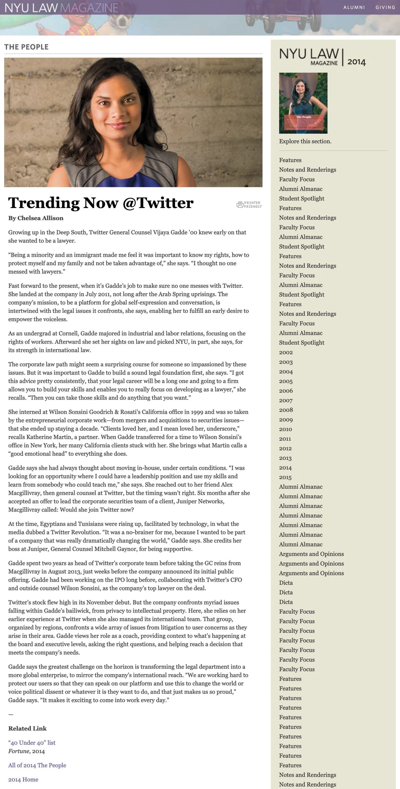
From the same, consider:
"At the time, Egyptians and Tunisians were rising up, facilitated by technology, in what the media dubbed a Twitter Revolution. “It was a no-brainer for me, because I wanted to be part of a company that was really dramatically changing the world,” Gadde says. She credits her boss at Juniper, General Counsel Mitchell Gaynor, for being supportive." - NYU Law Magazine [1]
What are the chances that then President Obama did nothing to promote and ensure success for the Arab Spring because its true purpose was to serve as a beta-test for the use of the Twitter platform in future censorship and color revolution applications in the U.S.?
The application of Occam's reveals that this is likely the case and Vadde's testimony here is evidence suggestive of this position.
WSGR product and central node Alex Macgillivray threads the Obama and Biden White Houses together. Macgillivray currently serves as the Biden White House CTO. Macgillivray appointed WSGR product Gadde to be his successor at Twitter and whereby Gadde was central both to the de-platforming of then President Trump and the censorship of the Hunter Biden laptop affair. It further aggravates the position on Twitter relative to engagement in color revolutions.
At the time, President Obama said this,
"The United States has supported the forces of change." - President Obama [2]
Obama did not say that he supported the countries of change but rather the forces of change; citing the countries as "inspiration".
Those are carefully constructed statements with specific word choice and when discernment is applied, we understand the "forces of change" to be digital ones, like Twitter. This comports with the Arab Spring being a Twitter Beta test. The same general people are now positioned to serve the Biden Administration on the follow-through.

"But the company [Twitter] confronts myriad issues falling within Gadde’s bailiwick, from privacy to intellectual property. Here, she relies on her earlier experience at Twitter when she also managed its international team....Gadde says the greatest challenge on the horizon is transforming the legal department into a more global enterprise, to mirror the company’s international reach. “We are working hard to protect our users so that they can speak on our platform and use this to change the world or voice political dissent or whatever it is they want to do, and that just makes us so proud,” Gadde says." - NYU Law Magazine [1]
Gadde's protections for voice and political dissent were full-stop at then President Trump when Gadde was central to his de-platforming. Contextually, we infer Gadde's comments to be descriptive of the "forces of change" then President Obama cited in reference to color revolutions, his engagement in them and the digital assets like Twitter's platform that are facilitating those revolutions.

ONGOING TWITTER CENSORSHIP
Recently, Twitter and Gadde's repeated pattern of evidenced censorship of conservative and COVID-19 related information continued. The Surgeon General for the State of Florida, Dr. Joseph Ladapo, was censored for an official advisement that read: "This analysis showed an increased risk of cardiac-related death among men 18-39. FL will not be silent on the truth." [3]
The FL Surgen General was referencing new guidance released by the state Health Department cautioning younger males [18-39] against receiving the COVID-19 mRNA vaccine. [3]
Twitter reinstated his post this past Sunday. [3]

WILSON, SONSINI, GOODRICH & ROSATI
Further investigation of WSGR indicates further reason for concern in overlapping domains of national interest: Twitter, deplatforming of President Trump, U.S. technology oversight, COVID-19, Hunter Biden Laptop, lipid nanoparticle envelopes [mRNA injection delivery mechanisms], and more.
Time limitations make the following appropriate for deeper investigation and findings for the next brief.
On 12 Jan 22, WSGR issued a press release [4] detailing its advisement on a $1 billiion series D capital financing deal. WSGR advised Checkout.com [5], which is an online payment processing platform.
According to WSGR, the Qatar Investment Authority [6] is featured as primary investor.
The Qatar Investment Authority is funding Elon Musk's purchase of Twitter [7]. WSGR represents Twitter in all corporate disclosures as discussed in the FIRST BRIEF.
Further focus on WSGR narrows to Katharine Martin, who "has been practicing law for more than 30 years. Since joining WSGR in 1999, she has represented high-profile technology companies, including LinkedIn, Twitter, Epicor Software, Plantronics, Seagate, Sun Microsystems, and Coherent." [8]
In October 2017, Markets Insider reports, "Wilson Sonsini Goodrich & Rosati is pleased to announced that Katharine (Katie) Martin will become Chair of the Board, its governing body, effective immediately. Katie will assume this responsibility from Larry Sonsini, who will remain active and engaged at the firm and continue to serve in his role as Senior and Founding Partner. As Chair of the Board, Katie will continue to work closely with the board, the firm's Managing Partner Doug Clark, and its practice leadership, to implement and carry out the firm's strategic and operational priorities. The position of Chairman of the Firm has been replaced by this new leadership structure." [9]
Martin's overlaps with the likes of Microsoft, Twitter and documented others give rise to concern regarding the entanglements of WSGR:
"Martin was a lead attorney on WSGR's team representing LinkedIn in its $26.2 billion sale to Microsoft. She was also was one of the lead partners representing Altera in its $16.7 billion sale to Intel. More recently, she led WSGR's team representing Brocade Communications in its $5.5 billion pending sale to Broadcom Limited and also led WSGR's team representing LifeLock in its $2.3 billion sale to Symantec.
Martin also has advised clients on a number of significant public offerings. In 2011, she was the lead attorney advising LinkedIn in its $352.8 million IPO, and was the lead attorney representing Twitter in its $2.1 billion IPO in 2013. In 2016, Martin advised BlackLine in its IPO and Juniper Networks in its $500 million senior note offering.
More recently, in a transaction announced on October 19, 2017, Martin was a lead attorney on the firm's team that represented Lyft in a $1 billion financing round led by CapitalG, Alphabet's growth investment fund." [9]
A recent development overlaps Microsoft and it's found in Konnech, Inc. [10] Konnech has conflict of interest in two domains where they offer data logistics [surveillance/intercedence] systems: COVID-19 and elections.
The COVID-19 conflict is found here [11]: "Konnech creates a COVID-19 tracking and reporting system to support safe workplaces and allowing clients to meet reporting standards set by state agencies."
From Konnech's home page [emphasis added [10]:
"At Konnech, election logistic software is all we do. For nearly 20 years we have been refining our software solutions based on the feedback and advice from the election managers we partner with and can confidently say that our technology is among the most effective, nuanced, and cost-saving in the industry. From Konnech’s first-client partnership with the City of Detroit to the 32 clients we currently work with in North America, our Founder and President, Eugene Yu, has implemented a client-centered approach. We listen to what you need in a system and will configure and customize our products so that you receive the exact solution you need."
As reported on 06 Oct 22, consider this from independent journalist Kanekoa [emphasis added] [12]:
"Eugene Yu, the CEO of the U.S. election software company Konnech, was arrested yesterday in connection to the storage of election data on Chinese servers.
He was arrested in Michigan by investigators from the Los Angeles County District Attorney’s office with assistance from the Meridian Township Police Department.
Investigators allegedly found U.S. poll workers’ information stored on servers in the People’s Republic of China."
Konnech is positioned to intercede on U.S. elections ergo China is positioned to intercede on U.S. elections.
U.S. poll workers become vulnerable to undue influence, bribery, compromise, etc. when their identities and information are know to hostile foreign enemies like China.
Konnech is positioned to have direct inroads to the CCP.
Konnech is a Microsoft Gold Partner and a Silver Partner since 2002. [10]
Further investigation is required and no direct Konnech/WSGR connections are known at this time beyond the Martin/Microsoft overlap.

BIDEN WHITE HOUSE
WSGR product and White House CTO Alexander Macgillivary is the spine of this censorship network threading through him to the Biden and Obama White Houses. It makes Macgillivray central to this recently released "Blueprint for an AI Bill of Rights".
The evidenced overthrow is a technocratic one. Digital assets have been leveraged across the board from perception management to electoral interference to thrusting forward color revolutions designed to deliver regime change and installed on-reservation Globalist puppets.
It is therefore imperative to view this Bill of Rights through a very particular lens: regardless of the "friendly" context framing the authorities and oversights, once oversight and authority is acquired, it stands to be bent back against the populace as an enforcement mechanism with the full weight of the entire federal apparatus behind it.
From the recent White House press release [13]:
"The Blueprint for an AI Bill of Rights addresses these urgent challenges by laying out five core protections to which everyone in America should be entitled:
- Safe and Effective Systems: You should be protected from unsafe or ineffective systems.
- Algorithmic Discrimination Protections: You should not face discrimination by algorithms and systems should be used and designed in an equitable way.
- Data Privacy: You should be protected from abusive data practices via built-in protections and you should have agency over how data about you is used.
- Notice and Explanation: You should know that an automated system is being used and understand how and why it contributes to outcomes that impact you.
- Alternative Options: You should be able to opt out, where appropriate, and have access to a person who can quickly consider and remedy problems you encounter.
Developed through extensive consultation with the American public, stakeholders, and U.S. government agencies, the Blueprint also includes concrete steps which governments, companies, communities, and others can take in order to build these key protections into policy, practice, or technological design to ensure automated systems work for the American people."
Any such oversight and authority stands to be bent back against the populace as an enforcement mechanism with the full weight of the entire federal apparatus behind it. Evidence of this is found in the events 9/11 [Patriot Act] and COVID-19 [unilaterally determined emergency use authorization occurring at the un-elected secretary level (HHS)].

EGON DURBAN
Egon Durban was linked in the FIRST BRIEF by means of Twitter's board, Silver Lake Capital and the WME Talent and Literary Agency, which intersects with Ari and Rahm Emanuel and the Obama White House.
The following is impacted by the fact set surrounding China's inroads to and influence over [control?] the NBA. [14] [15] [16]
The NY Post reports how Durban and his China/NBA ties overlay the Twitter/Musk deal [emphasis added] [17]:
"Elon Musk’s surprise offer to buy Twitter for his original price of $44 billion followed shrewd maneuvers by a board member who — in addition to a big stake in Twitter — also happens to own a chunk of the New York Knicks and Rangers, sources tell The Post.
Egon Durban — the founder and co-CEO of Silicon Valley hedge fund Silver Lake Partners, which owns about 10% of the Knicks and Rangers — took a hardline stance in negotiations with Musk when other directors appeared willing to take a settlement to end the legal standoff, sources close to the situation said."

MOVING FORWARD
Our findings in tsecond brief substantiate and expand the body of work established in the FIRST BRIEF. A third brief expanding on the first two is forthcoming.
SOURCES:
[1] https://blogs.law.nyu.edu/magazine/2014/trending-now-twitter/
[2] https://youtu.be/W0nr1cxAG44
[3] https://www.washingtonexaminer.com/news/twitter-reinstates-florida-surgeon-generals-tweet
[4] https://www.wsgr.com/en/insights/wilson-sonsini-advises-checkoutcom-on-dollar1-billion-series-d-financing.html
[5] https://www.checkout.com/
[6] https://www.investopedia.com/terms/q/qia.asp
[7] https://qatarday.com/qatar-investment-authority-contributes-375m-to-elon-musks-twitter-buyout
[8] https://markets.businessinsider.com/news/stocks/wilson-sonsini-goodrich-rosati-elects-katharine-martin-as-chair-of-the-board-1006330195
[9] https://markets.businessinsider.com/news/stocks/wilson-sonsini-goodrich-rosati-elects-katharine-martin-as-chair-of-the-board-1006330195
[10] https://www.konnech.com/
[11] https://web.archive.org/web/20201126050753/http://www.konnech.com/Company%20News.html
[12] https://kanekoa.substack.com/p/konnech-ceo-eugene-yus-connection
[13] https://www.whitehouse.gov/ostp/news-updates/2022/10/04/fact-sheet-biden-harris-administration-announces-key-actions-to-advance-tech-accountability-and-protect-the-rights-of-the-american-public/
[14] https://www.espn.com/nba/story/_/id/33938932/nba-owners-mum-china-relationship-more-10-billion-invested-there
[15] https://www.msnbc.com/opinion/nba-silence-china-proves-it-s-less-interested-human-rights-n1287663
[16] https://www.grunge.com/169768/the-conflict-between-china-and-the-nba-explained/
[17] https://nypost.com/2022/10/07/ny-knicks-co-owner-stands-to-reap-payday-from-twitter-musk-deal/amp/

